**READ ME**

1. Create a new folder on your CSE machine and Copy the files **Project2.tar.gz,** into this new folder.

Extraction of the project code:

1. We need to extract the **Project2.tar.gz** in the LINUX environment (I avoided extraction in windows because the extraction methods for LINUX and WINDOWS are completely different.) Use this command to untar the file (**Project2.tar.gz**): tar –zxvf Project1.tar.gz
2. It takes for about 20 minutes to extract everything. The speed of uploading and extraction depends on the configuration of the machine used.

Execution of the code:

1. Starting the Server on cse04.cse.unt.edu:
   1. Goto folder \Computer Networks\Project 2\Server
   2. Run the command

g++ -c -I ../Boost/boost_1_57_0 -I

../C++MySQLConnector/mysql-connector-c++-1.1.5-linuxubuntu12.04-x86-32bit/include main.cpp TCP_Connection.cpp

This command compiles all the files into object code.

* 1. Then, run this command

g++ -o a.out main.o TCP_Connection.o -L ../C++MySQLConnector/mysql-connector-c++-1.1.5-linuxubuntu12.04-x86-32bit/lib –lmysqlcppconn

This command links the object code along with the thirdparty library into one executable output file ‘a.out’

* 1. Finally, run this command

LD_LIBRARY_PATH=$LD_LIBRARY_PATH:/usr/local/lib ./a.out

It refers to a library when the code executes server connection is successfully established.

5. Open a browser and type….

<http://129.120.151.94:52216/www.msn.com>

the screenshot can be shown here..

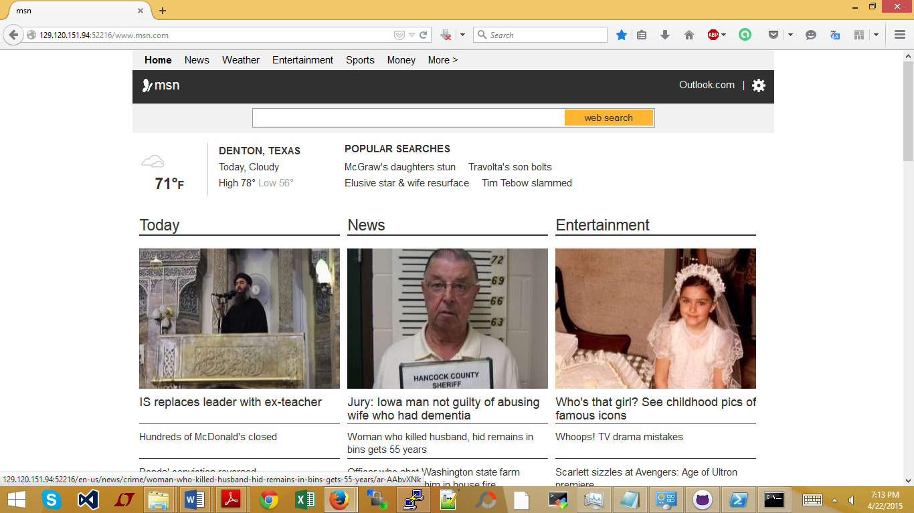

For another website http://129.120.151.94:52216/www.unt.edu

